Accessibility Guide for The Galson Campsite
tourism@uogltd.com , www.visitgalsonestate.com
Contact for accessibility enquiries: tourism@uogltd.com and 01851 850 393
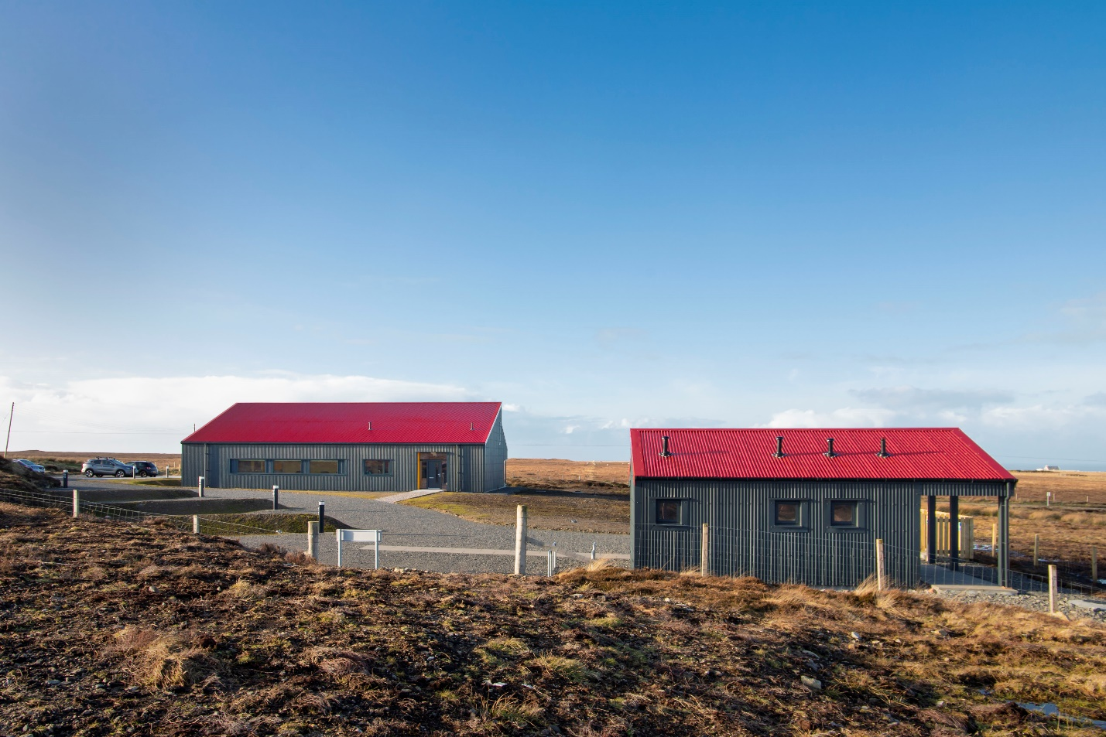

Welcome | Fàilte
The Galson Campsite is a community-owned campsite suitable for campervans, motorhomes and caravans and managed by Urras Oighreachd Ghabhsainn, the Galson Estate Trust. The site is situated at Tom na Bà in the village of South Galson, Isle of Lewis.
The Galson Campsite and its facilities are accessible 24 hours a day and are situated behind the Galson Estate Trust Business Centre.
The facilities both within the Galson Campsite and the Galson Estate Trust Business Centre are accessible for wheelchair users. We also offer a hearing loop in our Business Centre.
The toilet block at the Galson Campsite is occasionally used by members of the public and Urras Oighreachd Ghabhsainn allows this to avoid waste being left on its land.

At a Glance
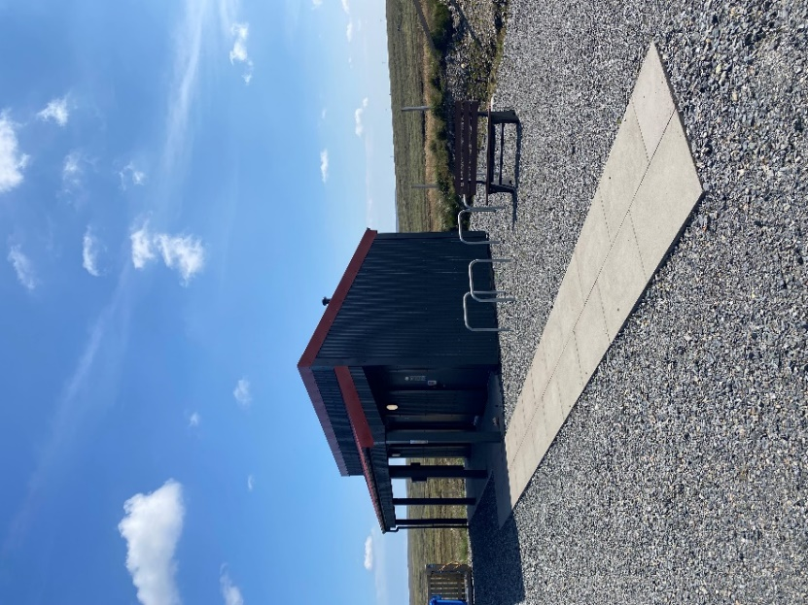
The Galson Campsite has one accessible pitch: pitch number 4. This pitch is closest to the facility block and has a strip of level slabs leading there (see photo).
Pitch 4.

Level Access
- The Galson Campsite facilities have level access to:
  - Accessible toilet with shower.

- The accessible toilet door at the Galson Campsite is 880mm wide or more with access to a level access shower. The door opens outwards.
- The accessible toilet door is 880mm wide. The door opens outwards.
- The bathroom has a level access shower. There is a shower chair available. The level access shower has handrails.
- The toilet has handrails. The direction of transfer onto the toilet is to the left. There is 200mm at the side of the toilet. On the right side there is 150mm at the side of the toilet
- There is 1900mm in front of the toilet. The toilet seat is 490mm high.
- The taps are lever operated. There is space under the basin, with no pedestal or boxing.
- The shower head can be lowered to 1490mm from the floor if required.

Getting here
Urras Oighreachd Ghabhsainn
Business Centre
Tom Na Bà
South Galson
Isle of Lewis
HS2 0SH

Travel by public transport
- You can reach the principal town of Stornoway by ferry and plane. The Galson Campsite and the Galson Estate Trust Business Centre are situated in the community of Ness, approximately 30 minutes’ drive from Stornoway town centre.
- The W1/W1A bus serves the Ness – Stornoway route. There is no bus stop but the bus will stop when requested; let the driver know in advance that you wish to disembark at Tom na Bà. Please be aware there is no bus shelter and no pavement, and the bus will drop you on a very busy road (60mph). The bus will stop approximately 150m from the Galson Estate Trust Business Centre and approximately 200m from the Galson Campsite facilities.

Mobility transport

HT Mobility provides wheelchair accessible transport with up to an additional 5 seats ensuring they can assist you to get around. They also provide an escort service which means you don't have to travel alone, wherever you want or need to go.
- Contact details – 01851 701111, bookings@hebcab.co.uk, www.hebrideantravel.co.uk

Parking
- The Galson Campsite does not have accessible car parking spaces.
- We have a car park at the Urras Oighreachd Ghabhsainn Business Centre where there is one accessible parking space. The parking is less than 50 metres from the main entrance and is tarmacked. Parking is free. There is a dropped kerb.
- From the car park to the main entrance of the Urras Oighreachd Ghabhsainn Business Centre, there is level access.
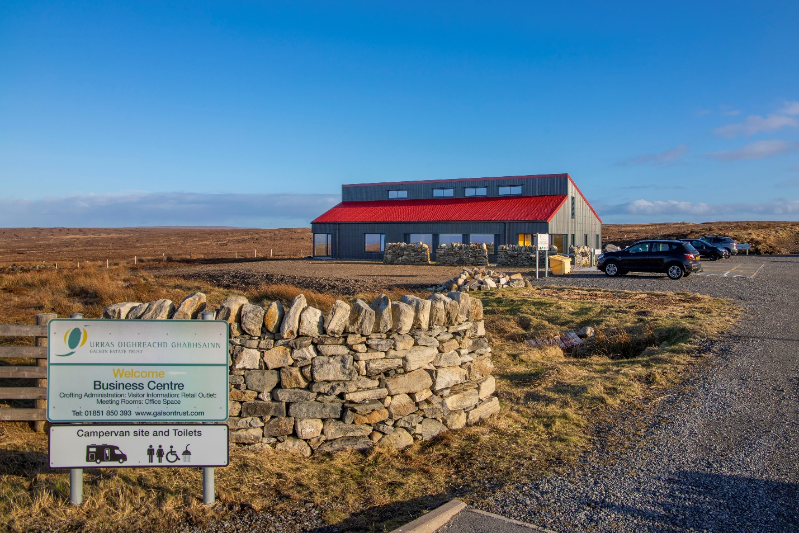
Business Centre from road view. The Campsite facilities are just behind the pictured building.

Path to facilities.

Pitches
- All pitches have LED-lit electric hook-up points.
- The surface of the motorhome, campervan and caravan pitches are stone chips.
- *Please note mobility might be difficult due to the stone chips*

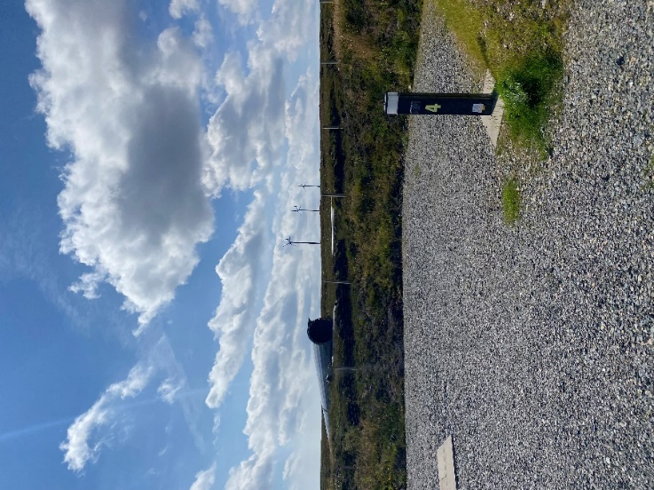

Accessible toilet
- The accessible toilet door is 880mm wide. The door opens outwards.
- The bathroom has a level access shower. There is a shower chair available. The level access shower has handrails.
- The toilets have handrails. The direction of transfer onto the toilet is to the left. There is 200mm at the side of the toilet. On the right side there is 150mm at the side of the toilet
- There is 1900mm in front of the toilet. The toilet seat is 490mm high.
- The taps are lever operated. There is space under the basin, with no pedestal or boxing.
- The shower head can be lowered to 1490mm from the floor if required.

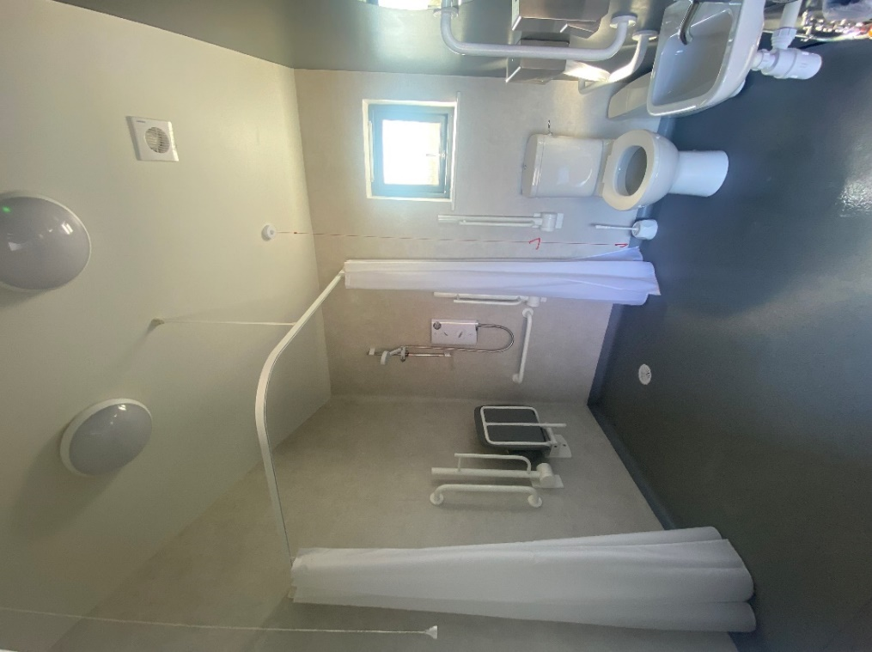
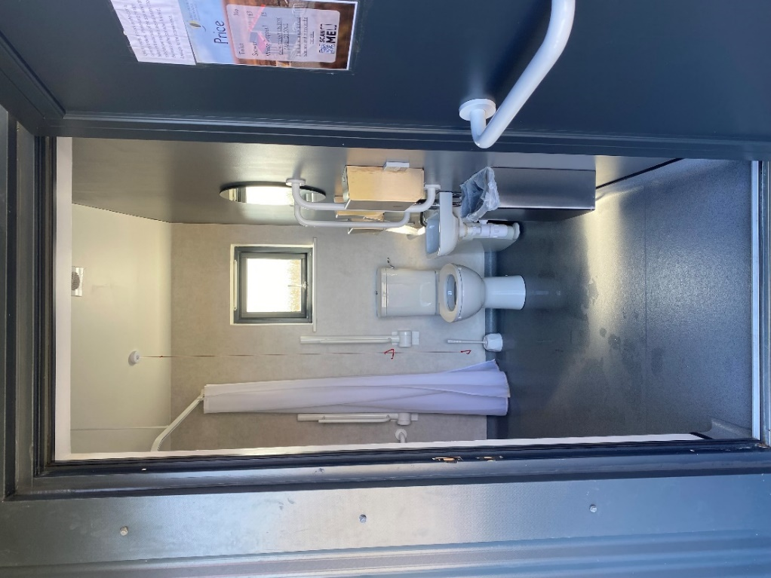

Customer care support

Accessibility equipment
- The nearest toilet area for assistance dogs is located anywhere within the perimeter of the Urras Oighreachd Ghabhsainn site.

Emergency evacuation procedures
- In an event of an emergency staff will assist you to your assembly point. If staff are not on site, please call Iain on 07923 846492 to report an out-of-hours emergency. Guests should congregate at the marked muster point at the UOG shed.

Customer care support
- The washroom facilities give details of local services and the emergency contact number – 07923 846492.
Mobile phone reception is variable depending on your network.
- WiFi is available: UOG Guest – UrrasG21

Guide last updated: 22 August 2022

